**Guide to the Arduino Mini**

To get started with the Arduino Mini, follow the directions for the regular Arduino on your operating system ([Windows](http://arduino.cc/en/Guide/Windows), [Mac OS X](http://arduino.cc/en/Guide/MacOSX), [Linux](http://www.arduino.cc/playground/Learning/Linux)), with the following modifications:

* Connecting the Arduino Mini is a bit more complicated than a regular Arduino board ([see below](http://arduino.cc/en/Guide/ArduinoMini#connecting) for instructions and photos).
* You need to select **Arduino Mini** from the **Tools | Board** menu of the Arduino environment.
* To upload a new sketch to the Arduino Mini, you need to press the reset button on the board immediately before pressing the upload button in the Arduino environment.

**Information about the Arduino Mini**

The microcontroller (an ATmega328) on the Arduino Mini is a physically smaller version of the chip on the USB Arduino boards, with the following small difference:

* There are two extra analog inputs on the Mini (8 total). Four of these, however, are not connected to the legs that come on the Arduino Mini, requiring you to solder wires to their holes to use them. Two of these unconnected pins are also used by the Wire library (I2C), meaning that its use will require soldering as well.

Also, the Arduino Mini is more **fragile and easy to break** than a regular Arduino board.

* Don't connect more than 9 volts to the +9V pin or reverse the power and ground pins of your power supply, or you might kill the ATmega328 on the Arduino Mini.
* You can't remove the ATmega328, so if you kill it, you need a new Mini.

**Connecting the Arduino Mini**

Here's a diagram of the pin layout of the Arduino Mini:

|  |  |
| --- | --- |
| http://arduino.cc/en/uploads/Guide/arduino_mini_pinout.png  *Mini 03 pinout* (compatible with earlier revisions) | http://arduino.cc/en/uploads/Guide/arduino_mini04_pinout.png  *Mini 04 and 05 pinout* (the ground on the left has moved down one pin) |

To use the Arduino Mini, you need to connect:

* Power. This can be a regulated +5V power source (e.g. from the +5V pin of the Mini USB Adapter or an Arduino NG) connected to the +5V pin of the Arduino Mini. Or, a +9V power source (e.g. a 9 volt battery) connected to the +9V pin of the Arduino Mini.
* Ground. One of the ground pins on the Arduino Mini must be connected to ground of the power source.
* TX/RX. These pins are used both for uploading new sketches to the board and communicating with a computer or other device.
* Reset. Whenever this pin is connected to ground, the Arduino Mini resets. You can wire it to a pushbutton, or connect it to +5V to prevent the Arduino Mini from resetting (except when it loses power). If you leave the reset pin unconnected, the Arduino Mini will reset randomly.
* An LED. While not technically necessary, connecting an LED to the Arduino Mini makes it easier to check if it's working. Pin 13 has a 1 KB resistor on it, so you can connect an LED to it directly between it and ground. When using another pin, you will need an external resistor.

You have a few options for connecting the board: the Mini USB Adapter, a regular Arduino board, or your own power supply and USB/Serial adapter.

**Connecting the Arduino Mini and Mini USB Adapter**

The circuit shown here is the basic setup for an Arduino mini connected to a USB-to-serial converter. You can see power and ground from the USB are run to the rails of the breadboard so it's convenient for the other components on the board. The 0.1uF capacitor from the reset pin is connected to the RTS pin on the mini USB adaptor. This enables auto-reset when the serial port is opened, meaning you don't have to press the reset button every time you upload new code. If it gives you problems, you can remove it, and press reset every time.

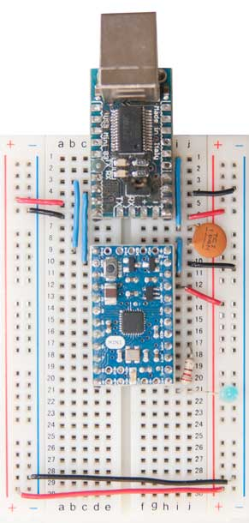

You can use a USBSerial connector wired up in a similar fashion :

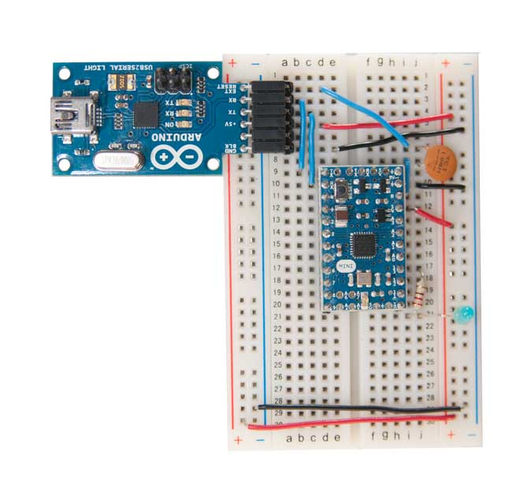

**Connecting the Arduino Mini and a regular Arduino**

Here's a photo of the Arduino Mini connected to an Arduino NG. The NG has its ATmega8 removed and is being used for its USB connection, power source, and reset button. Thus, you can reset the Arduino Mini just by pressing the button on the NG.

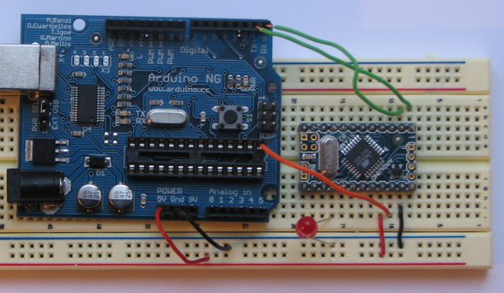

The text of the Arduino getting started guide is licensed under a [Creative Commons Attribution-ShareAlike 3.0 License](http://creativecommons.org/licenses/by-sa/3.0/). Code samples in the guide are released into the public domain.

[Bookmark and Share](http://www.addthis.com/bookmark.php?v=300&pubid=xa-50f052251629971d)

©Arduino | [Copyright Notice](http://arduino.cc/en/Main/CopyrightNotice) | [Edit Page](http://arduino.cc/en/Guide/ArduinoMini?action=edit) | [Page History](http://arduino.cc/en/Guide/ArduinoMini?action=diff) | [Printable View](http://arduino.cc/en/Guide/ArduinoMini?action=print) | [All Recent Site Changes](http://arduino.cc/en/Site/AllRecentChanges)

[Main Site](http://arduino.cc/en/) [Blog](http://blog.arduino.cc/) [Playground](http://playground.arduino.cc/) [Forum](http://arduino.cc/forum/) [Labs](http://labs.arduino.cc/) [Store](http://store.arduino.cc/ww/)

[Sign in](https://id.arduino.cc/auth/login/?returnurl=http%3A%2F%2Farduino.cc%2Fen%2FGuide%2FWindows) or [Register](https://id.arduino.cc/auth/register/?returnurl=http%3A%2F%2Farduino.cc%2Fen%2FGuide%2FWindows)

[Arduino](http://arduino.cc/en)

Top of Form



Bottom of Form

[Buy](http://arduino.cc/en/Main/Buy) [Download](http://arduino.cc/en/Main/Software) [Getting Started](http://arduino.cc/en/Guide/HomePage) [Learning](http://arduino.cc/en/Tutorial/HomePage) [Reference](http://arduino.cc/en/Reference/HomePage) [Products](http://arduino.cc/en/Main/Products) [FAQ](http://arduino.cc/en/Main/FAQ) [Contact Us](http://arduino.cc/en/Main/ContactUs)

**Getting Started w/ Arduino on Windows**

*This document explains how to connect your Arduino board to the computer and upload your first sketch.*

**On this page...** ([hide](javascript:toggle('tocid');))

* [1 | Get an Arduino board and USB cable](http://arduino.cc/en/Guide/Windows#toc1)
* [2 | Download the Arduino environment](http://arduino.cc/en/Guide/Windows#toc2)
* [3 | Connect the board](http://arduino.cc/en/Guide/Windows#toc3)
* [4 | Install the drivers](http://arduino.cc/en/Guide/Windows#toc4)
* [5 | Launch the Arduino application](http://arduino.cc/en/Guide/Windows#toc5)
* [6 | Open the blink example](http://arduino.cc/en/Guide/Windows#toc6)
* [7 | Select your board](http://arduino.cc/en/Guide/Windows#toc7)
* [8 | Select your serial port](http://arduino.cc/en/Guide/Windows#toc8)
* [9 | Upload the program](http://arduino.cc/en/Guide/Windows#toc9)

**1 | Get an Arduino board and USB cable**

In this tutorial, we assume you're using an [Arduino Uno](http://arduino.cc/en/Main/ArduinoBoardUno), [Arduino Duemilanove](http://arduino.cc/en/Main/ArduinoBoardDuemilanove), [Nano](http://arduino.cc/en/Main/ArduinoBoardNano), [Arduino Mega 2560](http://arduino.cc/en/Main/ArduinoBoardMega2560) , or [Diecimila](http://arduino.cc/en/Main/ArduinoBoardDiecimila). If you have another board, read the corresponding page in this getting started guide.

You also need a standard USB cable (A plug to B plug): the kind you would connect to a USB printer, for example. (For the Arduino Nano, you'll need an A to Mini-B cable instead.)

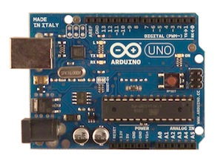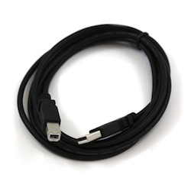

**2 | Download the Arduino environment**

Get the latest version from the [download page](http://arduino.cc/en/Main/Software).

When the download finishes, unzip the downloaded file. Make sure to preserve the folder structure. Double-click the folder to open it. There should be a few files and sub-folders inside.

**3 | Connect the board**

The Arduino Uno, Mega, Duemilanove and Arduino Nano automatically draw power from either the USB connection to the computer or an external power supply. If you're using an Arduino Diecimila, you'll need to make sure that the board is configured to draw power from the USB connection. The power source is selected with a jumper, a small piece of plastic that fits onto two of the three pins between the USB and power jacks. Check that it's on the two pins closest to the USB port.

Connect the Arduino board to your computer using the USB cable. The green power LED (labelled **PWR**) should go on.

**4 | Install the drivers**

**Installing drivers for the** [**Arduino Uno**](http://arduino.cc/en/Main/ArduinoBoardUno) **or** [**Arduino Mega 2560**](http://arduino.cc/en/Main/ArduinoBoardMega2560) **with Windows7, Vista, or XP:**

* Plug in your board and wait for Windows to begin it's driver installation process.  After a few moments, the process will fail, despite its best efforts
* Click on the Start Menu, and open up the Control Panel.
* While in the Control Panel, navigate to System and Security. Next, click on System. Once the System window is up, open the Device Manager.
* Look under Ports (COM & LPT).  You should see an open port named "Arduino UNO (COMxx)"
* Right click on the "Arduino UNO (COmxx)" port and choose the "Update Driver Software" option.
* Next, choose the "Browse my computer for Driver software" option.
* Finally, navigate to and select the driver file named **"arduino.inf"**, located in the "Drivers" folder of the Arduino Software download (not the "FTDI USB Drivers" sub-directory). If you are using an old version of the IDE (1.0.3 or older), choose the Uno's driver file named **"Arduino UNO.inf"**
* Windows will finish up the driver installation from there.

See also: [step-by-step screenshots for installing the Uno under Windows XP](http://arduino.cc/en/Guide/UnoDriversWindowsXP).

**Installing drivers for the** [**Arduino Duemilanove**](http://arduino.cc/en/Main/ArduinoBoardDuemilanove)**,** [**Nano**](http://arduino.cc/en/Main/ArduinoBoardNano)**, or** [**Diecimila**](http://arduino.cc/en/Main/ArduinoBoardDiecimila) **with Windows7, Vista, or XP:**

When you connect the board, Windows should initiate the driver installation process (if you haven't used the computer with an Arduino board before).

On Windows Vista, the driver should be automatically downloaded and installed. (Really, it works!)

On Windows XP, the Add New Hardware wizard will open:

* When asked **Can Windows connect to Windows Update to search for software?** select **No, not this time**. Click next.
* Select **Install from a list or specified location (Advanced)** and click next.
* Make sure that **Search for the best driver in these locations** is checked; uncheck **Search removable media**; check **Include this location in the search** and browse to the **drivers/FTDI USB Drivers** directory of the Arduino distribution. (The latest version of the drivers can be found on the [FTDI website](http://www.ftdichip.com/Drivers/VCP.htm).) Click next.
* The wizard will search for the driver and then tell you that a "USB Serial Converter" was found. Click finish.
* The new hardware wizard will appear again. Go through the same steps and select the same options and location to search. This time, a "USB Serial Port" will be found.

You can check that the drivers have been installed by opening the Windows Device Mananger (in the Hardware tab of System control panel). Look for a "USB Serial Port" in the Ports section; that's the Arduino board.

**5 | Launch the Arduino application**

Double-click the Arduino application. (Note: if the Arduino software loads in the wrong language, you can change it in the preferences dialog. See [the environment page](http://arduino.cc/en/Guide/Environment#languages) for details.)

**6 | Open the blink example**

Open the LED blink example sketch: **File > Examples > 1.Basics > Blink**.

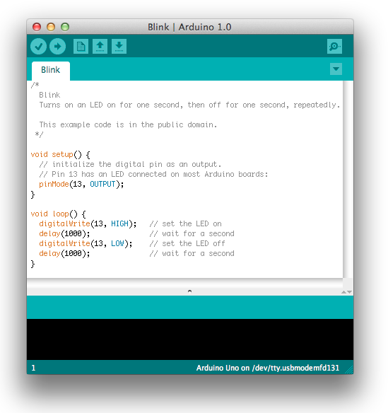

**7 | Select your board**

You'll need to select the entry in the **Tools > Board** menu that corresponds to your Arduino.

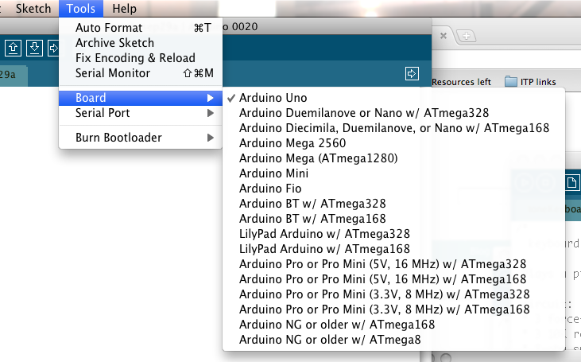

Selecting an Arduino Uno

For Duemilanove Arduino boards with an ATmega328 (check the text on the chip on the board), select **Arduino Duemilanove or Nano w/ ATmega328**. Previously, Arduino boards came with an ATmega168; for those, select **Arduino Diecimila, Duemilanove, or Nano w/ ATmega168**. (Details of the board menu entries are available [on the environment page](http://arduino.cc/en/Guide/Environment#boards).)

**8 | Select your serial port**

Select the serial device of the Arduino board from the Tools | Serial Port menu. This is likely to be **COM3** or higher (**COM1** and **COM2** are usually reserved for hardware serial ports). To find out, you can disconnect your Arduino board and re-open the menu; the entry that disappears should be the Arduino board. Reconnect the board and select that serial port.

**9 | Upload the program**

Now, simply click the "Upload" button in the environment. Wait a few seconds - you should see the RX and TX leds on the board flashing. If the upload is successful, the message "Done uploading." will appear in the status bar. (*Note:* If you have an Arduino Mini, NG, or other board, you'll need to physically present the reset button on the board immediately before pressing the upload button.)

http://arduino.cc/en/uploads/Guide/UploadButton.png

A few seconds after the upload finishes, you should see the pin 13 (L) LED on the board start to blink (in orange). If it does, congratulations! You've gotten Arduino up-and-running.

If you have problems, please see the [troubleshooting suggestions](http://arduino.cc/en/Guide/Troubleshooting).

You might also want to look at:

* the [examples](http://arduino.cc/en/Tutorial/HomePage) for using various sensors and actuators
* the [reference](http://arduino.cc/en/Reference/HomePage) for the Arduino language

The text of the Arduino getting started guide is licensed under a [Creative Commons Attribution-ShareAlike 3.0 License](http://creativecommons.org/licenses/by-sa/3.0/). Code samples in the guide are released into the public domain.

[Bookmark and Share](http://www.addthis.com/bookmark.php?v=300&pubid=xa-50f052251629971d)

©Arduino | [Copyright Notice](http://arduino.cc/en/Main/CopyrightNotice) | [Edit Page](http://arduino.cc/en/Guide/Windows?action=edit) | [Page History](http://arduino.cc/en/Guide/Windows?action=diff) | [Printable View](http://arduino.cc/en/Guide/Windows?action=print) | [All Recent Site Changes](http://arduino.cc/en/Site/AllRecentChanges)